**Home Work 1**

1. **scribe the capability of the Raspberry Pi and its suitability for different project types.**

**Ans:**

As we know the raspberry pi board is a mini computer and have very high computing speed.so these devices can be used in any type of projects. Mostly these devices are used for embedded system applications and also for inter-attached embedded system application, IOT projects, vending machine and all those projects that can be done by using other microcontrollers. The raspberry pi board plays an important role in the field of image processing due to the open source availability of Pi cam and high computing efficiency.

The other microcontrollers can run only one language or only single operating system while raspberry pi can run different operating systems and programming languages even at a same time. The raspberry pi board can be used to run any field of project either it’s a Bio-medical project, electrical project, electronics project, computer-based project or machine learning project. The raspberry pi board plays an important role in the advancement of machine learning and artificial intelligence. The artificial intelligence is implemented on the robots by using raspberry pi boards along with the image processing which provide visualization scope to robots to interact with other things.

The raspberry pi can be used in any type of difficult project. Its processing speed and computing speed make good combination to boost its performance. In the field of electrical and electronics engineering the engineers are using this board at a very large scale to make their projects in the field of power engineering, robotics engineering, swarm globalization, computer engineering, data science, making servers and many online projects.

1. **Describe the major hardware systems and subsystems of your RPi. Use the textbook, RPi documentation, and Broadcom data sheets to justify your answer.**

**Ans:**

In the heart of the board, the raspberry pi uses the Broadcom BCM2835, BCM2836 and BCM2837 system on chip. The major hardware system of the Raspberry Pi board includes the microprocessor, RAM, micro SD card slot, SPI and I2C interface through which PI cam is attached to the raspberry pi board. Further Bluetooth module, wireless network module and ethernet adapter is built-in connected with the board which allow the board to connect with other network and devices. In modern boards there are 4 USB ports in which two of the USB ports are 3.0 speed while the remaining two USB porta are with 2.0 USB speed. There is 40 GPIO pins are available on the board which are divided into two columns (20 x 2). The sensors, actuators, relays and other devices are connected by using GPIO pins. Further the board has HDMI port to import display on any LCD screen and also an audio adapter is connected on the board.

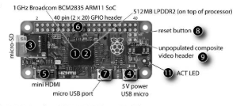

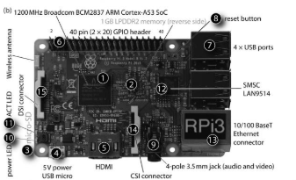

The major system and subsystem on the board are above explained. But as we know the raspberry pi board has different version according to different specifications. So, the user mostly confused which one he buys. So, for the ease of the user, A comparison chart including all the major system and subsystem of the raspberry pi board is made and pasted below. So, the user can buy board according to his requirements. The chart showing different models of system on chip (SOC) of Broadcom.

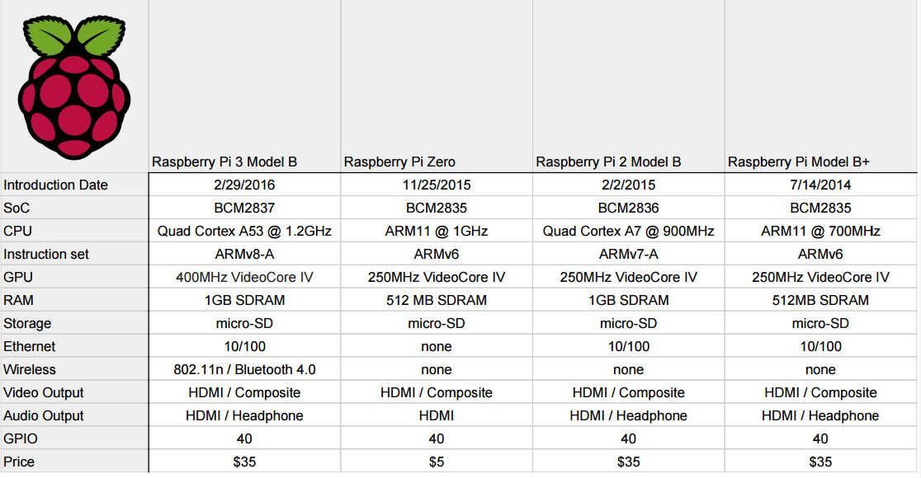

1. **List the steps to take in protecting your RPi from physical/electrical damage.**

**Ans:**

As we know the Raspberry pi is a sensitive board with all the system on chip board. So, we have to protect this board physically and electrically. For protecting the board physically, we must place our raspberry pi board at a safe place and clean.

For protecting the raspberry pi physically, you can buy raspberry pi case. It is different for different models of raspberry pi. So, cover your raspberry pi with its case. This will save our raspberry pi from any kind of damage and also from dust particles. The raspberry pi case saves the board from moisture which is the main reason of getting carbon on the pins of the components and become rust. Also, moisture short circuit the board which in the end damage the whole board. Moreover, the case of the Pi saves board from mechanical deformity.

While protecting the raspberry pi from electrical damage is very necessary. The raspberry pi case plays an important role to protect board from electrical damage. For example, if your board has no case and you put you board on a metal surface then the soldering of the components on the board become short circuited due to the metal surface which make contact between high and low potential terminals. So, the case of raspberry pi protects our board.

As we know the board is full of semi-conductor devices that are working on very high frequency so the board components become heated and when board is running for a very long time than processor and RAM of the board are too heated. So, we use heat sinks attached on the body of the processor (CPU) and RAM of the board. But we noticed the heat is increasing even by the use of heat sinks. For better control of heat and for cooling purposes we use cooling fan that is powered by the board itself to cool the board temperature.

So, we can protect our board electrically and physically damage by the use of board case, heat sinks and cooling fan.

1. **Describe your approach for setting up your RPi. Explain how you connected it to a network (wired or wireless) and any problems you encountered during setup.**

**Ans:**

The setup of Raspberry pi model 3B+ is very easy. First of all, download Raspbian Buster latest from the Raspberry Pi official website. Now you must have a SD card to run OS on raspberry pi. Also format your SD card using SD card formatter tool. Copy this OS image into your SD card using image writing tools e.g. Etcher. After copying put your SD card into the raspberry pi and turn on, at this point I imagine our raspberry pi is already set with display screen and other peripheral devices like mouse and keyboard etc. When you boot up your raspberry pi, it will show some initial setting about your locale, keyboard setting, date& time, RPi password etc. You can change password at this point and also connect your raspberry pi with the Wi-Fi or Ethernet according to which is easily available.

When I finish booting my raspberry pi and doing its configuration setting, the raspberry pi asks to connect it with wireless network as we know already that the raspberry pi has built-in wireless module. So, I enter in this setting and I some available wireless networks are showing, I scroll down and connect with my home network by entering the network password. Also, raspberry pi has option to connect to network via Ethernet port. You can connect your raspberry pi with network by connecting the Ethernet wire one side in wireless router and other in Ethernet port of the raspberry pi.

The problem I encountered and then solved while doing the RPi setup is when I try to enter the network password when connecting to wireless network. The keyboard layout is different and it will show wrong character as compared to the character I pressed so I come to know that like other professional computers the raspberry pi also has different keyboard layouts. So, I go to raspberry pi configuration and change the keyboard layout. So, in this way I solve the problem and the Raspberry Pi setup is completed successfully.